Author Guidelines for the TeanGEO 2018 Conference
– This is the Paper Title (Times New Roman, 16pt, bold, centred)

Mohamed Ben Salem¹, Habib Rannene²

¹University of Tunis El Manar, Ecole nationale d’ingénieurs de Tunis, Tunisia, msalem@enit.rnu.tn
²University of Carthage, Institut national agronomique de Tunis, Tunisia, ranneneh@yahoo.fr

NB for peer reviewed papers: In order to preserve the author’s anonymity and to ensure a double-blind review process, authors are requested to remove author names and affiliations (those that appear immediately under the paper title) from the initial submission. Once the paper has been reviewed and accepted or amended, the names and affiliations should be restored to the final submission. Authors are also advised to remove their names from the file properties of the document.

Abstract
Abstract of the paper, 150-250 words. Use Times New Roman, 12pt, italics, with line spacing of at least 18pt. Indent the first line of the paragraph with 0.5cm. Justify the text in a paragraph on the left and right hand side. Separate sections with a single line.

Introduction
The TeanGeo 2016 Conference is an ideal opportunity to learn about recent advances, future developments and potential research avenues. The topics will span the multiple disciplines within the Geospatial Science & Technology field, covering the full spectrum from educational opportunities to cutting-edge presentations of new and original scientific research. It will also promote and showcase the latest products and services the industry has to offer.

The papers submitted for peer review should be original and should not have been previously published, nor should it be submitted for another conference or be submitted to a journal for consideration for publication. Referencing should be comprehensive and should adequately reference previous research in this area.

Manuscript Submission
This template is a Guide for Authors to provide a style guide for authors to enable the submitted paper to be in a format as near as possible to the format of the final version of the paper. It is intended to benefit to the author in that the entire paper (text, tables, and graphics) may be submitted in one file. Inserting graphics and tables close to the point at which they are discussed in the text of the manuscript can also be a benefit for the reviewer. The paper should be submitted electronically as a MSWord document (.doc format, .docx format, .pdf format only) to the web page of the conference (www.teangeo.org). The paper, including figures, tables, references and appendixes should not be longer than twelve pages, and the file size should not exceed 6MB. It is essential that authors adhere to these style guidelines.

Copyright and Disclosure

Copyright
Authors who submit papers agree to the following terms:
a) Authors retain copyright over their work, while allowing the conference to place this work on the conference website under a Creative Commons Attribution Licence, which allows others to freely access, use, and share the work, with an acknowledgment of the work's authorship and its initial publication in this conference proceedings.
b) Authors are able to waive the terms of the CC licence and enter into separate, additional contractual arrangements for the non-exclusive distribution and subsequent publication of this work (e.g., post it to an institutional repository or publish it in a book), with an acknowledgment of its initial publication in this proceedings.
c) In addition, authors are encouraged to post and share their work online (e.g., in institutional repositories or on their website) at any point after publication on the conference website.

Disclosure
If the submission must be cleared or approved by your institution, company or government agency before publication, the author(s) should ensure that they have the necessary permission in writing to the effect that the information described in the paper, can be made public on the conference website. Author(s) and/or their organizations retain(s) the right to reuse the work in whole or in part, and the publishers of the conference proceedings do not control the commercial use of material that is published. However, the conference organisers will assume that all submissions have been duly cleared by the author(s), and that the author(s) have permission to disclose information contained in the submission.

Paper formatting guidelines (Times New Roman, 14pt, bold)

General (Times New Roman, 12pt, Bold)
The table below summarises the most important aspects of the desired layout of the paper.

Table 1. Formatting summary
Item | Description
Page size & margins | A4 Portrait; all margins 2cm
Page numbers | Yes, starting at 1
Footer / Headers | None (NB: footnotes are not permitted)
Title | Times New Roman, 16pt, bold, centred - followed by a single blank line
Author and co-authors | Times New Roman, 12pt, centred - author and co-author names in one line, followed by a single blank line.
Author affiliations | Times New Roman, 12pt, centred – each author’s full affiliation (i.e. company / organization), full contact details of the corresponding author only, followed by two blank lines.
Abstract | Times New Roman, 12pt, Italics, with line spacing of at least 18pt. Indent the first line of the paragraph with 0.5cm. Justify the text in a paragraph on the left and right hand side. Separate sections with a single line. 150 - 250 words
Headings | Times New Roman, 14pt, bold, left justified, in proper case, one blank line above.
Sub-headings | Times New Roman, 12pt, bold, left justified, in proper case, one blank line above.
Sub-sub-headings | Times New Roman, 12pt, italic, left justified, in proper case, one blank line above.
Heading numbering | Use the decimal system of heading numbering, with no more than three levels.

Body Text (Times New Roman, 12pt, bold)
Body Text should be Times New Roman, 12pt, with line spacing of at least 18pt. Indent the first line of the paragraph with 0.5cm. Justify the text in a paragraph on the left and right hand side. Separate sections with a single line.

Symbols and units (Times New Roman, 12pt, bold)
SI units should be used. Where abbreviations for units are used, there should be no space between the value and the unit - i.e. ‘10km’, not ‘10 km’.

Equations (Times New Roman, 12pt, bold)
Equations should be numbered in square brackets e.g. [1] consecutively through the text. The equation should be indented by 2cm, with the equation number right justified. Equation Editor (MSWord97-2003) or MathType should be used to create the equations. Either plain or italics style may be used for the variables, as long as there is consistency in style. Use boldface for vectors and matrices. . .

[1]

Figures, photographs and illustrations (Times New Roman, 12pt, bold)
To insert graphics within the text or as a figure, chart, scheme, or table, create a new line and insert the graphic where desired. Figures should be provided in a standard format (e.g. jpeg, tiff, bmp), and should be of high resolution (450dpi). Figures shall be numbered consecutively with a brief caption, which should be in Times New Roman, 12pt, below the figure, centred, and not in bold. The figure, photograph or illustration should also be centered. Authors are encouraged to make use of colour in all graphics, figures and photographs. The figure should be located in the document, as close as practicable to the first reference to it. Refer to the example below. If your graphic is not visible, ensure that the Word Style is “Normal” with an automatic height adjustment. All figures must be mentioned in the text consecutively and numbered with Arabic numerals. The caption should be understandable without reference to the text.

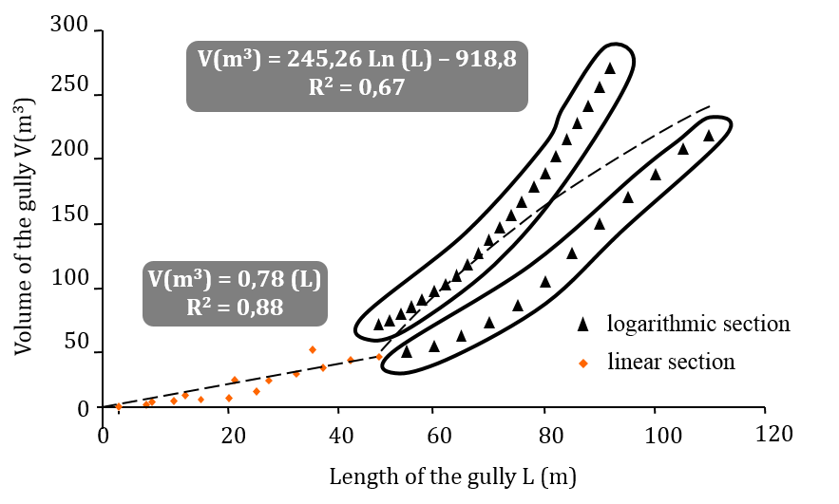
Figure 4. Volume of the gullies depending on their lengths (Times New Roman, 12pt, centered)

Tables (Times New Roman, 12pt, bold)
Tables should be numbered consecutively and should have a caption. The table caption should be in Times New Roman, 12pt, positioned above the table, centred, and not in bold. Text inside the table should preferably be Times New Roman, 10pt, with the headings in bold. Each table must have a brief title that describes its contents. The title should be understandable without reference to the text. Each table shall be located in the document as close as practicable to the first reference to it. Refer to the example below.

Table 1. Sediment yield (m3/ha.year) resulting from headward recession of gullies
 |  | Period 1 | Period 2 | Period 3 | Period 4 | Period 5
Catchment N° | Area (ha) | x1 | x2 | x3 | x4 | x5
1 | 2.68 | 1.022 | 0.944 | 0.076 | 0.108 | 0.340
2 | 3.01 | 0.944 | 0.832 | 0.0635 | 0.077 | 0.300
3 | 2.11 | 1.011 | 0.763 | 0.047 | 0.059 | 0.403
4 | 1.89 | 1.008 | 0.570 | 0.053 | 0.0669 | 0.403
Total |  | 3.987 | 3.110 | 0.240 | 0.312 | 1.448

References (Times New Roman, 12pt, bold)
For references, use Times New Roman, 11pt, indentation hanging by 0.5cm. Use a line spacing of at least 15pt. Use the Harvard style for referencing. References should be listed in alphabetical order and presented as shown in the examples at the end of this document. References should follow one another, with no blank lines in between. Authors are responsible for the accuracy and completeness of all references.

References should be indicated in the text in brackets with the last name of the first author and year of publication as in: (Maaoui et al., 2012). Personal communications (including email) should only be referenced in the text (Ben Salem, personal communication, September 2013), and should not be included in the list of references. Example references are shown below.

Book
Author Year, Book Title, Edition (if any), Publisher, Place of publication. Example:
Czinkota, MR and Ronkainen AI, 2004, International marketing, 7th edition, Thomson/South-Western, Mason, Ohio.

Chapter in Book
Author Year, ‘Chapter’ Edition (if any) in Editors Book Title Publisher, Place of publication. Example:
North, D 1980, ‘Energy use at home’, in S Scott, and N Peel (eds.), Energy conservation, Academic Press, London.

Full-text journal article
Author Year, 'Article title', Journal Title, volume, issue, pages. Example:
Rasid, ZM & Parish, TS 1998, 'The effects of two types of relaxation training on students' levels of anxiety', Adolescence, vol. 33, no. 129, pp. 99-110.

Conference Proceedings
Author Year, 'Article title', in Editors Proceedings Title, Place and date of conference, pages, Publisher, Place and date of publication. Example:
Merry, CL 1990, 'Recent variations in Mean Sea Level in Southern Africa', in H Sünkel and T Baker (eds.), Sea Surface Topography and the Geoid, Edinburgh, July 1989, pp. 149-157, Springer-Verlag, New York, 1990.

Journal article on the WWW
Author Year, 'Article title', Journal Title, volume, issue, viewed Day Month Year, <URL>. Example:
Griffith, AI 1995, 'Coordinating family and school: mothering for schooling', Education Policy Analysis Archives, vol. 3, no. 1, viewed 12 February 1997, <http://olam.ed.asu.edu/epaa/>.

Web document
Author/editor or compiler Year of the most recent version, Title, version number (if applicable), description of document (if applicable), name and place of the sponsor of the source, viewed Day Month Year, <URL either full location details or just the main site details>. Example:
Anderson, J (Minister for Transport and Regional Services) 2000, CASA approves avgas contamination test, media release, 23 January, Department of Transport and Regional Services, Canberra, viewed 7 February 2000, <http://www.dotrs.gov.au/media/anders/archive/2000/jan_00/al6_2000.htm>.

Web document (no author)
Title Year, version number (if applicable), description of document (if applicable), name and place of the sponsor of the source, viewed Day Month Year, <URL either full location details or just the main site details>. Example:
Educating America for the 21st century: developing a strategic plan for educational leadership by Columbia University 1993-2000(initial workshop draft) 1994, draft workshop report, Institute for Learning technologies, Columbia University, viewed 16 May 1995, <http://ariel.adgrp.com/~ghb/trips/940717_ICT/policy/ILT/EdPlan.html>.

Web document (no publication date)
Author n.d., Title, version number (if applicable), name and place of the sponsor of the source, viewed Day Month Year, <URL either full location or just main site details>. Example:
Sherman, C n.d., The invisible web, Free Pint Limited, UK, viewed 27 November 2000, <http://www.freepint.co.uk/issues/080600.htm#feature>.

Web site
Author (the person or organisation responsible for the site) Year (that the site was created or last revised), name and place of the sponsor of the source, viewed Day Month Year, <URL>. Example:
The Body Shop Australia 2003, The Body Shop Australia, Mulgrave, Victoria, viewed 31 January 2003, <http://www.thebodyshop.com.au/>.

January 2017

